**COVID-19 Authorization Letter**

test

To whom it may concern

The One Click Solutions Management hereby gives **Hello World – HELWOR001** permission to visit the offices.

Reason: Test

Contact: Test

Duration: Test

Yours Sincerely,

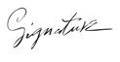

Ammar Canani

CEO One Click Solutions